**Outline**

We use Semantic HTML to select HTML elements based on their meaning rather than how they are displayed. This lesson will introduce you to Semantic elements in HTML.

**Overview**

**Topics introduced**

* Introduction to Semantic HTML
* Why use Semantic HTML?
* Div Tag
* Header and Nav
* Section Article and Footer
* Difference between Section and Div

**Topics in Detail -**

**Introduction to Semantic HTML**

* We generally use a combination of non-semantic HTML and semantic HTML when creating web pages. Because **semantic elements provide information about the content between the opening and closing tags, they are named after the word semantic, which means "relating to meaning."**
* We use Semantic HTML to select HTML elements based on their meaning rather than how they are displayed. Elements such as and are not semantic elements because they provide no context for what is contained within those tags.
* Example - Instead of using an element to hold our header information, we could use an element that serves as a heading section. We provide context for what information is inside the opening and closing tags by using a tag instead of a.

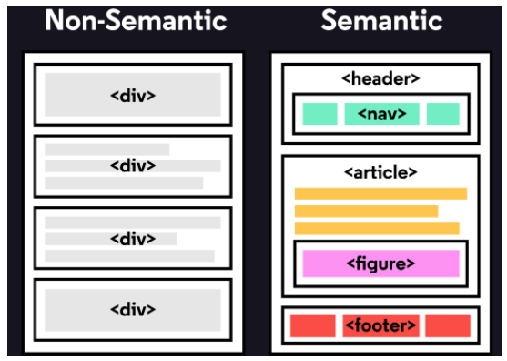

**Why use Semantic HTML?**

**Accessibility:** Semantic HTML makes web pages available to mobile devices and people with disabilities. This is due to the improved ability of screen readers and browsers to interpret the code.

**SEO:** It enhances the website. SEO, or Search Engine Optimization, is the process of increasing the number of visitors to your website. With improved SEO, search engines can better identify your website's content and appropriately weigh the most important content.

**Simple to Understand:** Semantic HTML makes the source code easier to read for other web developers.

**Div Tag**

* In an HTML document, the <**div>** tag defines a division or section.
* The div tag contains HTML elements, which are then styled with CSS or manipulated with JavaScript.
* The **class or id attribute** makes it simple to style the div tag.
* The div tag can contain any type of content!
* Browsers, by default, place a line break before and after the div element.
* Syntax -

**<div class="myDiv">**

**Content goes here…**

**</div>**

**Header and Nav**

* A **<header>** is a container that typically contains either navigational links or introductory content with h1 to h6 headings.

Our code becomes easier to read by using a header tag. It is much easier to identify what is inside the h1's parent tags than it is to identify what is inside a div tag, which provides no details about what is inside the tag.

* A **<nav>** is a block of navigation links such as menus and tables of contents. It is important to note that nav can be used both inside and outside of the header element.

**Example -**

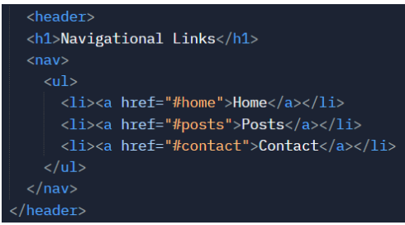

**Output -**

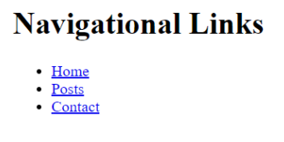

**Section, Article and Footer**

Now that we've covered the body of Semantic HTML let's look at what else can go in there.

**Section -**

* The term **<section>** refers to elements in a document such as chapters, headings, or any other area of the document that has the same theme.
* For example, content having the same theme, such as cricket articles, can be grouped together in a single section.
* The home page of a website could be divided into sections for the introduction, news items, and contact information.

**Article -**

* The **<article>** element contains content that stands on its own.
* Articles, blogs, comments, magazines, and other types of content can be held in an article.
* An article tag would assist someone using a screen-reader understand where the article content (which could include a combination of text, images, audio, and so on) begins and ends.

**Example -**

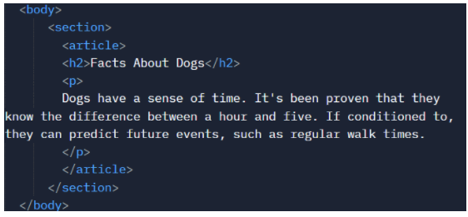

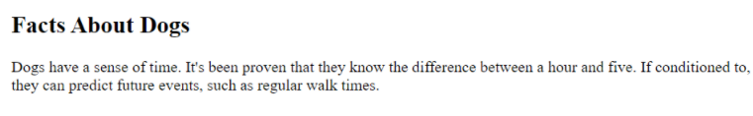

**Note -** The **<aside>** element indicates extra information that can help another element but isn't necessary to understand the main content.

**Footer -**

The footer, which is indicated by the <footer> element, is the content at the bottom of the subject information. The footer includes details such as:

1. Getting in Touch
2. Copyright details
3. Terms and Conditions
4. a reference to the links at the top of the page

**Example -**

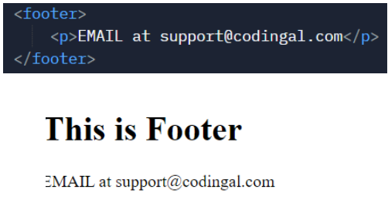

**Difference between Section and Div**

* The div element has no special significance. It is frequently used as a building block for children's elements.
* The HTML5 section element is used to group related elements, such as a subsection of a long article.
* In short, the section element is more semantically rich than the div element.